How do we reflect on the coaching relationship?
Coaching
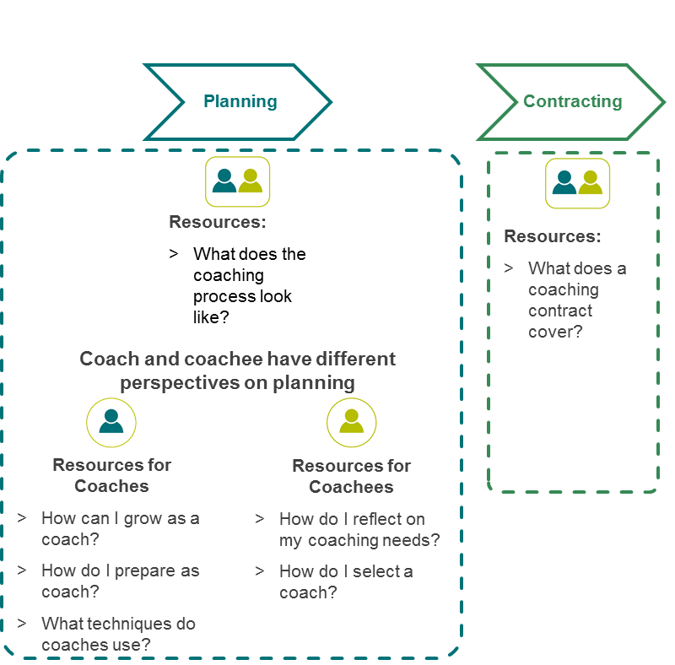
Coaching toolkit overview
Coaching

How do we reflect on the coaching relationship?
Reflecting on the coaching relationship is vital to the learning process for both the coach and coachee. This activity will be useful for reflecting on the coaching relationship while it is ongoing and when you reach the end of the coaching relationship. This reflection can help you to assess next steps and how to transition the relationship.
Refer to your coaching contract to remind yourself of agreed commitments and goals. Both coach and coachee should also reflect on their own professional learning.

Revisiting my goals
What were the goals of the coaching relationship? | Obstacles encountered | How have I progressed?
What were my personalised learning goals? | Obstacles encountered | How have I progressed?

How was I successful?
What did I do particularly well?

What can I do now that I couldn’t do before?

What did I do to overcome any obstacles?

What did I learn about myself?
Did I find the coaching experience valuable? Why/why not?

What did I learn about myself that I didn’t know before?

How can I use this learning in the future?

What do I need to continue working on?
What didn’t go well?

What am I still challenged by?

What might I do to continue to address these challenges?

Continuing the learning process
Was the coaching relationship an effective professional learning tool to address the identified development needs? Why/why not?

What is my next learning opportunity?

What support may I need from others?

Do I want to continue the coaching relationship? Why/why not?

What could I do to get more out of my next coaching experience?

If we make the decision to end the formal coaching relationship, are there opportunities for us to connect in a different way? E.g. continue informal catch-ups, formally catch up once, twice a year etc.

