Reflection and
goal setting
Ongoing feedback, reflection and review
Professional practice
and learning
Performance
and
Development
How do I reflect on my own goal achievement?
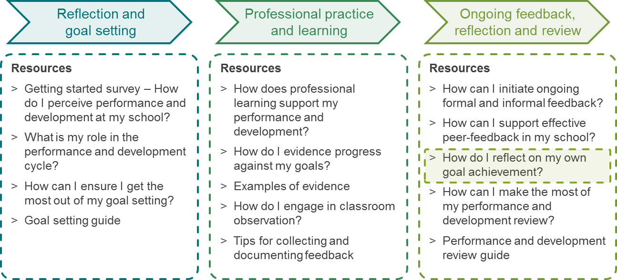
Reflection and
goal setting
Ongoing feedback, reflection and review
Professional practice
and learning
Performance and development toolkit overview
Performance and Development

How do I reflect on my own goal achievement?
Self-reflection is an invaluable source of insight. To gain an ongoing understanding into your own goal achievement, it is important to regularly reflect on the goals you set in your performance and development plan. This will help you to monitor your progress toward your goal(s), assess the appropriateness of evidence, make changes as required and prepare for your annual review.
Consider blocking out some time in your diary each week to allow for self-reflection.
This document outlines exercises to support self-reflection on your goal achievement.

Self-reflection exercise 1: Activities that support your goals
Think about the goals you set for this year in your performance and development plan. Looking back at the past week or month, what activities have you undertaken to work towards any of your goals?
Capture your reflections:
Goal | Activities undertaken | Did the activities help (+) or hinder (-) goal achievement. Why? | How did the activities evidence progress against the goal? | What are the key learnings?  For example, is further work required on these activities, or adjustments to the type of evidence you are seeking?

Self-reflection exercise 2: Personal effectiveness
Think about a specific recent situation in which you felt very effective in relation to achieving one of your goals. Capture your reflections:
Goal | Situation / What made you feel effective? / What did you do? | What are the key learnings from the situation?

Self-reflection exercise 3: Improvement opportunities
Think about a specific recent situation in which you felt less effective in relation to achieving one of your goals. Capture your reflections:
Goal | Situation / What made you feel less effective? / What did you do? / What hindered your effectiveness? | What are the key learnings from the situation?

Self-reflection exercise 4: Progress of goal achievement
Think about the goals you set for this year in your performance and development plan. Looking back at the year so far, how far have you progressed towards achieving your goals? What specific activities are required from here to ensure that you will achieve your goals?
Capture your reflections:
Goal | Current status of goal achievement | What specific activities will you undertake from here to achieve your goal?

Self-reflection “on the go”:
Below is a template for a pocket-sized card that allows for quick reference "on the go" both with respect to your goals and self-reflection. Capture each goal in a couple of words and note them on the left side. Then print, fold and laminate the card for easy reference.
My performance and development goals: | Self-reflection “on the go” - Reflect upon effective and less effective situations:
- ………………………………………………  - ………………………………………………  - ………………………………………………  - ………………………………………………  - ……………………………………………… | - What happened and why?  - What did I think and how did I feel before, during and after?  - What did I say and do? Why?  - What was the impact of my action?  - What will I do again and what will I do differently next time?

