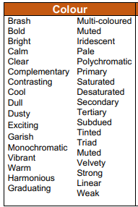
Artwork 1:
What colours can you see in this artwork? Write in the box below
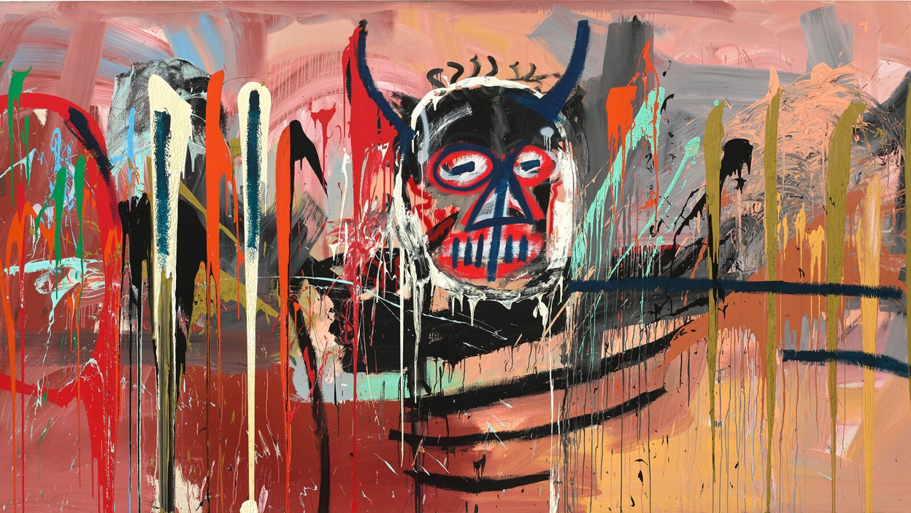
(Use the glossary words to help)

Jean-Michel Basquiat, Untitled,” in acrylic and spray paint on canvas, 1982
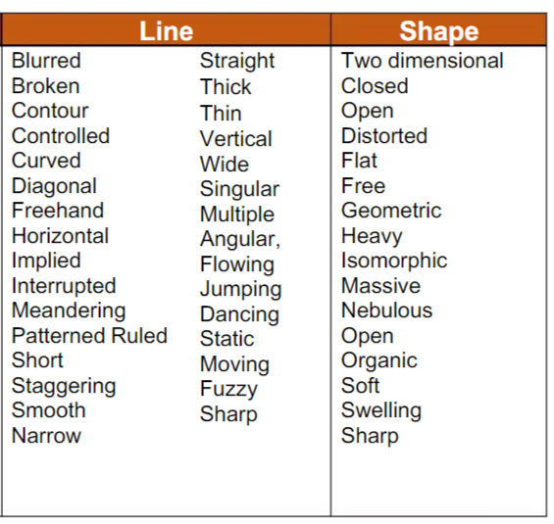
Artwork 2: What type of LINES and SHAPES can you see in this artwork?
(Use the glossary words to help)
Jean-Michel Basquiat Untitled, 1981
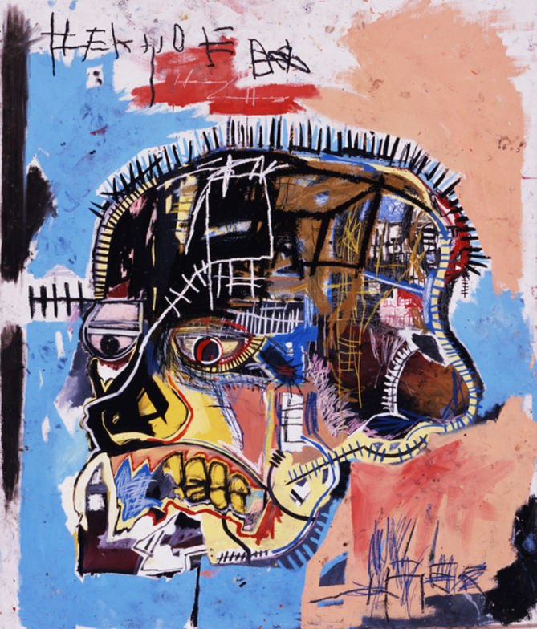

Artwork 3: Write down 3 expressionist characteristics can you notice in this Basquiat’s artwork?
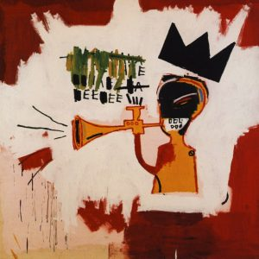
Jean-Michel Basquiat, Trumpet , acrylic and crayon on canvas 1984
Some characteristics of Basquiat’s work
- Symbolism (e.g. crown)
- Mixed mediums
- Text
- Thickly applied paint
- Skulls
- Quickly drawn subjects
- Scrawled (hurried) drawn characters
- A link between his upbringing and heritage
1.

2.

3.

